Name :SK.Kashifa

Registration no :192121135

Vehicle registration system :

Class diagram :

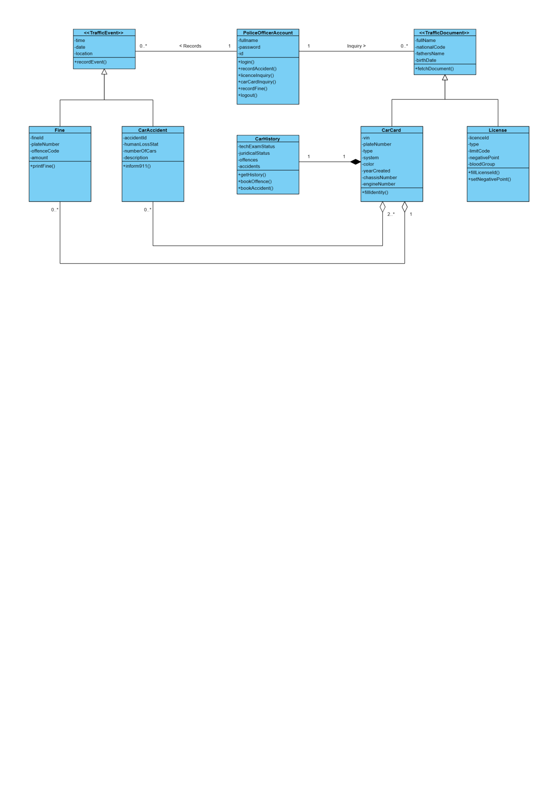

Usecase diagram :

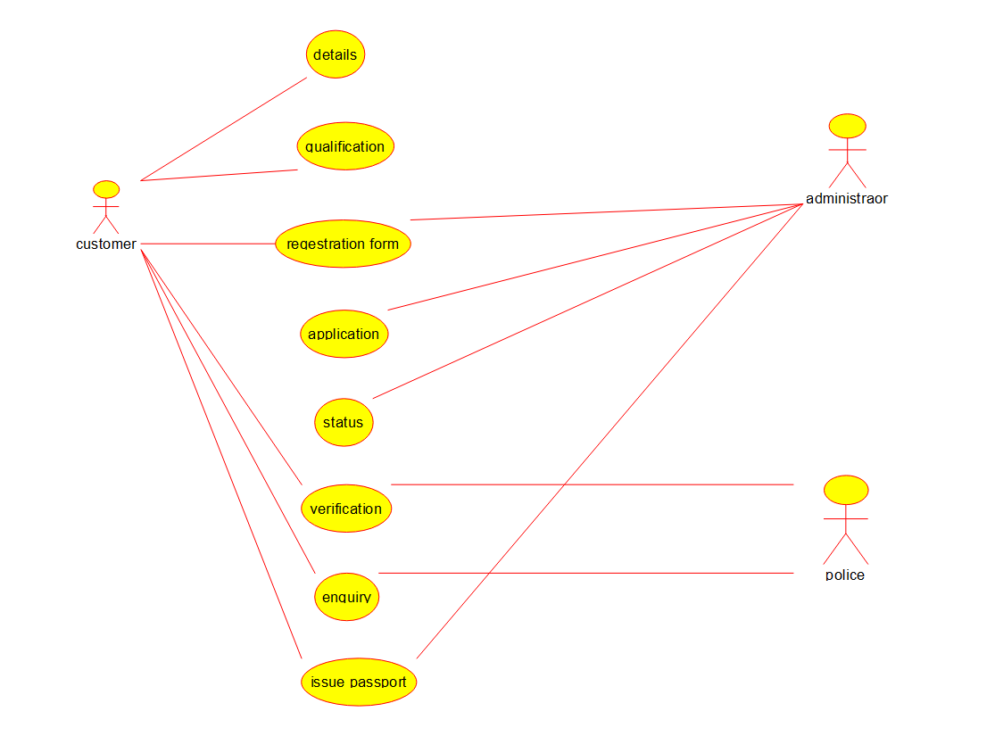

Deployment diagram :

